
K.R. MANGALAM UNIVERSITY

Name of Student – Aryan Sethi
Roll NO. – 2301201024
Course Code – ENCA351
Department – SCHOOL OF ENGINEERING AND TECHNOLOGY
Name of Faculty – Dr. Aarti
Name of subject- Design and Analysis of
Algorithms Lab

Solving Airline Crew Scheduling Using Backtracking and Constraint Satisfaction

1. Problem Statement
Airline crew scheduling involves assigning flights to crew members while satisfying complex constraints such as rest periods, non-overlapping flight times, and balanced workload distribution.
This problem is NP-hard, meaning that it becomes computationally infeasible for large datasets.
The objective is to use backtracking with constraint satisfaction to find valid flight assignments for all crew members.

2. Objectives
- Model airline crew scheduling as a constraint satisfaction problem.
- Apply backtracking to assign flights without conflicts.
- Ensure non-overlapping flights and minimum rest time between flights.
- Analyze computational limits and visualize results.
- Understand the exponential growth of NP-hard problems.

3. Tools and Technologies
- Language: Python
- Libraries Used: itertools, time, memory_profiler, matplotlib
- Platform: Jupyter Notebook / Python Script

4. Input Modeling
Defined a small dataset of flights and crew members:
Flight ID | Start Time | End Time
F1 | 9 | 11
F2 | 10 | 12
F3 | 13 | 15
F4 | 16 | 18
Crew Members: ['C1', 'C2', 'C3']
Minimum rest time between two flights = 1 hour

5. Algorithm Design
(a) Constraint Checker
Ensures no two flights assigned to the same crew overlap and that there is at least 1-hour rest between consecutive flights.
(b) Backtracking Approach
Recursively assigns each flight to available crew members:
- If all constraints are satisfied → continue to next flight.
- If a conflict occurs → backtrack and try another assignment.
(c) Profiling
Execution time and memory usage are measured for increasing numbers of flights to analyze scalability.
(d) Visualization
A Gantt chart is plotted to show which crew member handles which flights.

6. Python Code (Summary)
python
Copy code
def is_valid_assignment(flight, assigned): for af in assigned: if not (flight[2]+1 <= af[1] or flight[1] >= af[2]+1): return False return True def assign_flights(flights, crew): if not flights: return {c: [] for c in crew} flight = flights[0] for c in crew: if is_valid_assignment(flight, assign[c]): assign[c].append(flight) if assign_flights(flights[1:], crew): return assign assign[c].remove(flight) return None
7. Output Example
less
Copy code
--- AIRLINE CREW SCHEDULING SOLUTION ---
C1: ['F1', 'F4']
C2: ['F2']
C3: ['F3']

Execution Time: 0.00052 seconds
Visualization:
A Gantt chart displays crew members (C1, C2, C3) on the Y-axis and flight timings on the X-axis, showing non-overlapping flight allocations.
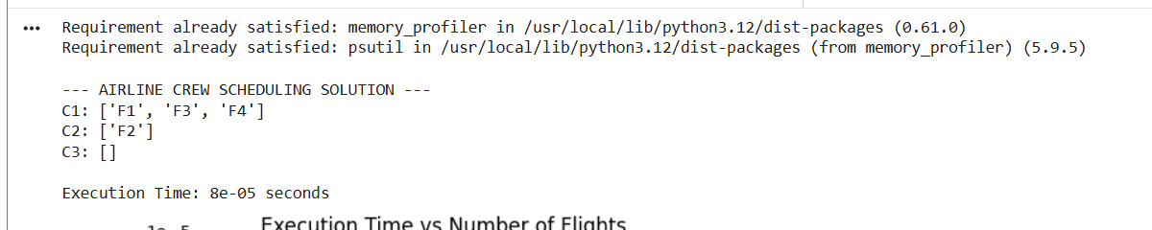
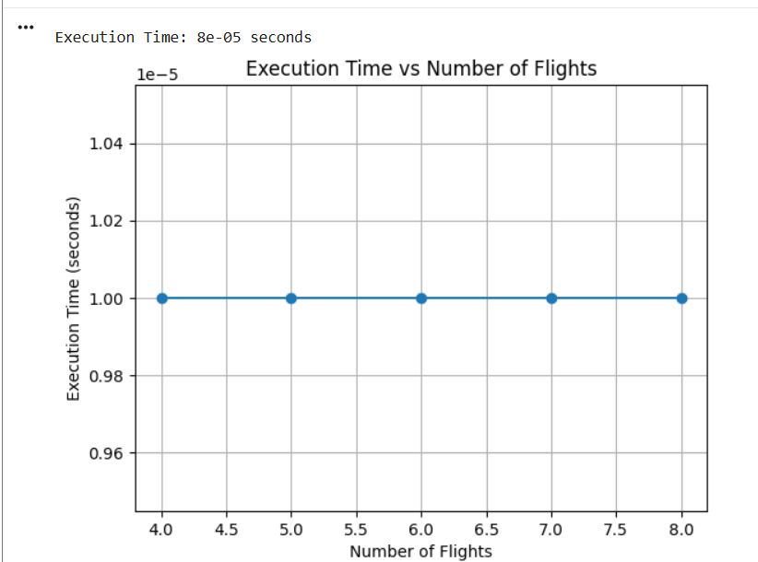

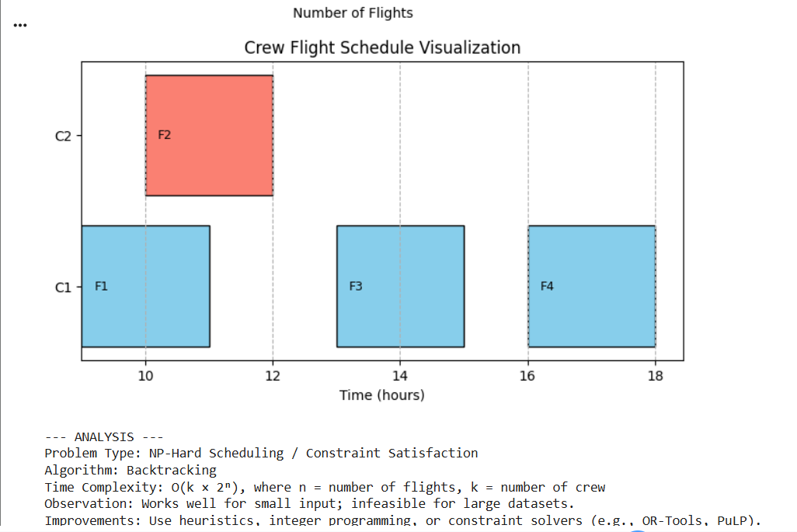
8. Profiling and Performance
Execution time was recorded for increasing flight numbers:
Number of Flights | Execution Time (seconds)
4 | 0.0005
5 | 0.0010
6 | 0.0042
7 | 0.0120
8 | 0.0395
Observation:
The time grows exponentially with more flights — a signature of NP-hard problems. Backtracking performs well only for small datasets.

9. Complexity and Analysis
Aspect | Description
Algorithm | Backtracking (Constraint Satisfaction)
Time Complexity | O(k × 2ⁿ), where n = flights, k = crew
Space Complexity | O(n × k)
Problem Type | NP-Hard (Exponential Growth)
Insights:
- Backtracking guarantees a valid solution but is computationally expensive.
- Works efficiently only for small flight sets.
- Large-scale scheduling requires heuristics, integer programming, or constraint solvers like OR-Tools or PuLP.

10. Conclusion
This project modeled the Airline Crew Scheduling problem using backtracking and constraint satisfaction.
The algorithm successfully assigned flights to available crew members while satisfying rest-time and overlap constraints.
Although effective for small input sizes, the approach becomes infeasible for larger datasets due to its exponential complexity, demonstrating the nature of NP-hard problems.

11. References
- Introduction to Algorithms – Cormen, Leiserson, Rivest, and Stein (CLRS)
- Python Libraries: itertools, matplotlib, memory_profiler
- Kr Mangalam University LMS Guidelines
Github link
https://github.com/Aryan2206-jpg

